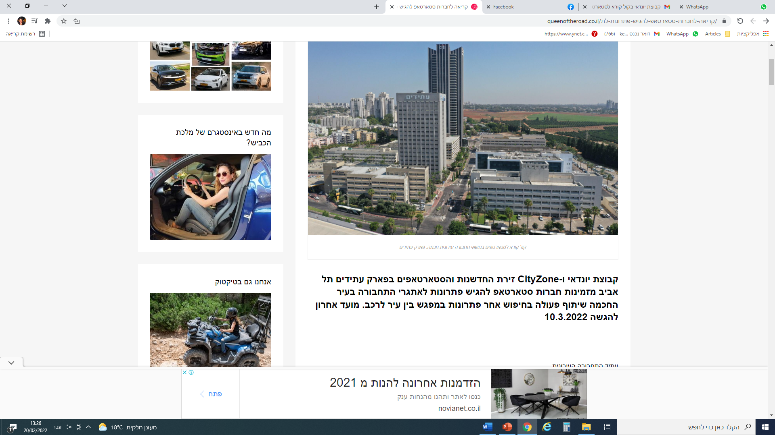

<https://www.queenoftheroad.co.il/%D7%A7%D7%A8%D7%99%D7%90%D7%94-%D7%9C%D7%97%D7%91%D7%A8%D7%95%D7%AA-%D7%A1%D7%98%D7%90%D7%A8%D7%98%D7%90%D7%A4-%D7%9C%D7%94%D7%92%D7%99%D7%A9-%D7%A4%D7%AA%D7%A8%D7%95%D7%A0%D7%95%D7%AA-%D7%9C%D7%AA/>